We have an issue Coding Pathologic TNM – Stg and Regional Nodes Positive/Examined and Edits on the following Scenario. The Edit appears all due to the sequence of events.

Scenario:

2/5/16 Patient diagnosed C508, 8520/32.

2/15/16 Right mastectomy with SLN excision, 3/3 lymph nodes positive.

3/16 to 6/16 Chemotherapy

7/20/16 Completion of right axillary node dissection, 2/12 lymph nodes positive.

Descriptor 4 indicating neoadjuvant chemotherapy was not assigned since chemo was not administered prior to mastectomy and 3/3 SLN excision.  Chemotherapy was given before the ALND but after the mastectomy.

cT3cN0cM0 Clinical Stage 2B

pT3pN1a cM0 Pathological Stage 3A

(Chapter 1, page 9 “Timing Rule” indicates pathological staging window has closed since patient received chemotherapy 3/16 to 6/16. Therefore, cannot include 7/20/16 right axillary node dissection results (2/12 LN) in pathological N.

However, 7/20/16 Right ALND is captured in Regional Nodes Positive & Examined:

Regional Nodes Positive 05

Regional Nodes Examined 15

The following edit is received when pN1a is assigned: EDIT Details at the bottom.

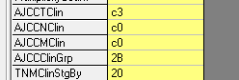

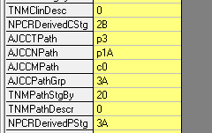

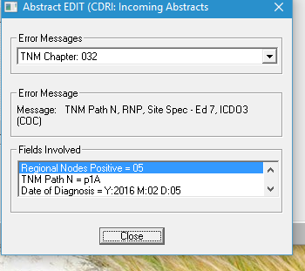

No edit is received when pN2a is assigned:

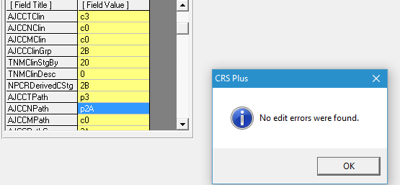

Edit Details – TNM Path N RNP, Site Spec – Ed7, ICDO3 (COC)

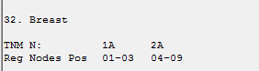

How do you assign Pathologic TNM, Stage and Descriptor on this case, when neoadjuvant treatment was prior to node dissection but NOT prior to tumor removal and sentinel node bx? AND How do you code the Regional Nodes Positive/Examined?

Thank you,

CDRI